High level architecture diagram:
- Android GUI

- Android Java Application

- Database
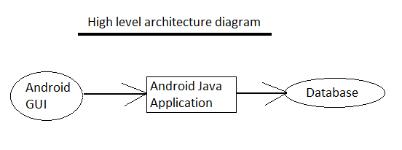

Component level design:
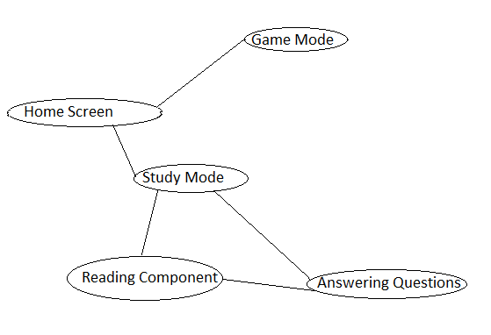
Potential Classes:
- class HomeScreen
- class StudyModeScreen
- class PlayModeScreen
- class QuestionOne
- class ReadingAssignmentOne
- class Points
- class PurchaseItem
- class QuestionOption
- class ReadingOption
- class TestYourKnowledge
User Flow:
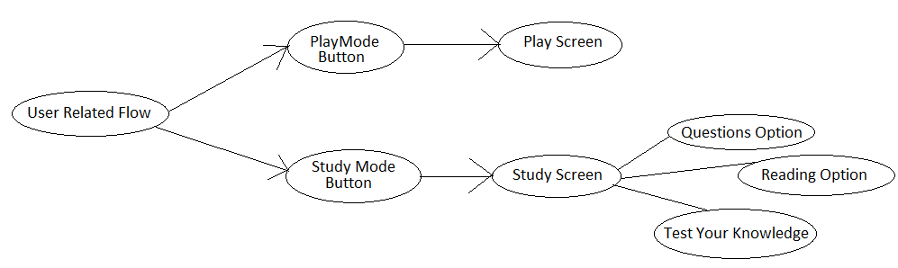
UI level design sample:
